**ProgressBook GradeBook**

**Point of Contact Guide**

Updated: August 2018

**Items listed with an “*” or in bold red are NOT to be modified by GradeBook/PB POC’s. This information is maintained by OME-RESA Staff unless otherwise noted. Please consult this documentation prior to making *any* changes to your data.**

**IMPORTANT—Please use this Admin manual provided by OME-RESA. Do not use the documentation provided in the application as it is completely different. If you have any questions, please contact Student Services.**

**Table of Contents**

End User Requirements for Version 17.0.0 4

Additional Configurations Supported by ParentAccess 4

Pop-up Blockers 4

Login 5

Administration Home Page 5

*Named Codes Section 6

District Setup Section 6

District 6

Schools 7

*Grade Levels 8

*Rooms 8

Lunches 8

*District Features 9

*School Features 9

*3rd Party API Settings 10

Annual Setup Section 10

*School Calendars 10

*Homerooms 10

*Courses 11

*Classes 12

*Students 12

Staff 13

Explanation of Roles 13

Disable Staff 14

Transfer Staff Activity 14

To delete staff members 16

Help a Teacher 16

Grading Setup Section 18

Reporting Periods 18

Enter Report Card Entry Dates 19

*Cross Reference 19

*Mark Types / Grading Scales 20

*Report Card Builder 20

Tools Section 21

Miscellaneous Section 21

Check Software Version 21

*Data Integration Status 22

Recalculate Gradebooks 22

Delete Students 22

Update Email Address 22

Change your Password 23

Reports 24

Report Builder Reports 26

Report Cards 27

Generate Preliminary Report Cards 27

View Saved Preliminary Report Cards 28

Generate Final Report Cards 29

View Saved Final Report Cards 30

Finalize Report Cards 31

Print Final Report Cards 33



# End User Requirements for Version 18.0.0

The tables below are a guideline for end users. The ProgressBook Suite has been successfully tested using these product and version configurations. Other configurations may work without issue; however, these are the versions actively tested and supported.

|  |  |  |
| --- | --- | --- |
| **Operating System** | **Browser** | **Adobe Acrobat Reader** |
| **Apple** |  |  |
| macOS v10.13 “High Sierra” | Safari v11.x | DC |
| **Microsoft** |  |  |
| Windows 7 SP1  Windows 8.1  Windows 10 | Internet Explorer 11 Firefox v59**1**  Google Chrome v66**1** | DC |

## Additional Configurations Supported by ParentAccess

|  |  |
| --- | --- |
| **Operating System** | **Browser** |
| **Apple** |  |
| iOS 11 | Safari |

## Pop-up Blockers

The GradeBook/PB application displays the PDF documents in a pop-up window. You must disable any pop-up blocker in order for the GradeBook/PB application to function properly. Pop-up blockers vary based on operating system, browser version, and third party tools such as the Google Toolbar, etc. Check your system settings, and be sure to enable pop-ups for the GradeBook/PB website.

# Login

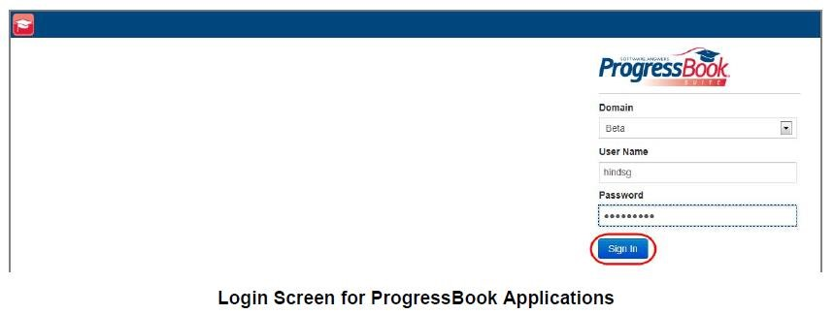

# Administration Home Page

The picture below is the “Administration Home Page” for GradeBook/PB. Each procedure in this guide will refer to this page.

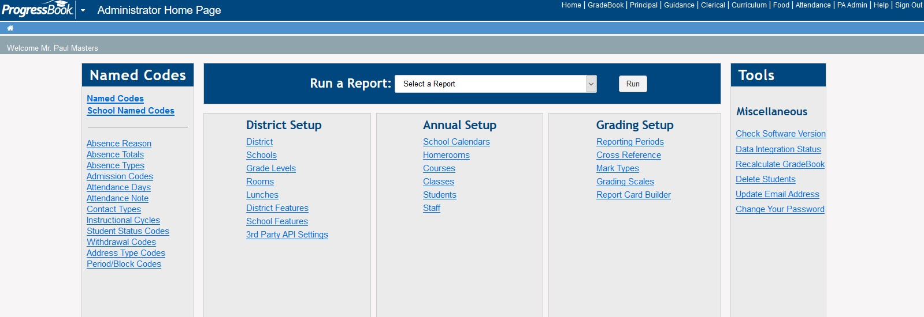

*Note: Menu options for each role are located at the top of the page. This will allow an administrator to gain access to all parts of the application.*

# *Named Codes Section

Named codes lists are set up and maintained to specify the attendance-related codes, student status and other codes used in each school in your district. GradeBook provides default named codes groups for you to use that remain in the system regardless of whether your district is integrated with a student information system. Once you have set up the named codes lists, they remain in your system from year to year. If changes are necessary, you should make them to the named codes lists in that student information system.

**\*Note: OME-RESA will maintain allitems in this area. Please refrain from using this section.**

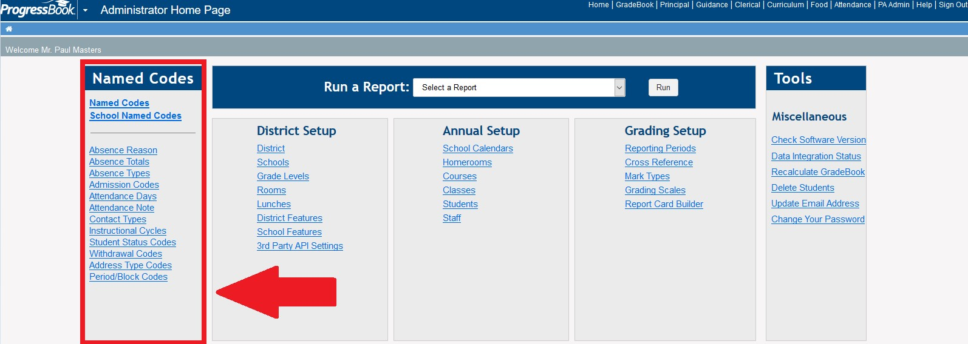

# District Setup Section

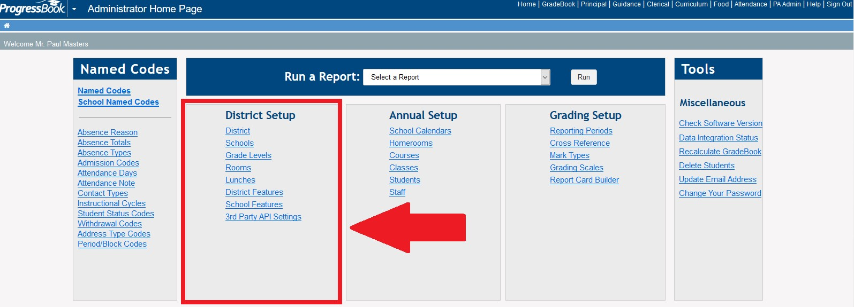

## District

Click on District under District Setup

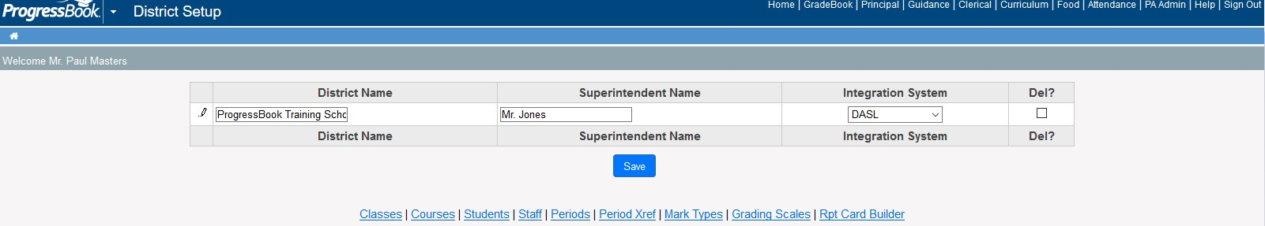

* District Name field – Please do not update the District Name
* Superintendent Name – This field you will want to update so that the reports and report cards reflect the correct Superintendent. Simply click in the field to update the name. • Integration System – This should always be DASL

## Schools

Schools are imported into GradeBook from StudentInformation, so any changes should be made in StudentInformation. Please do NOT add or delete schools.

You may click the arrow to view the school’s information. However, if you need to make any updates, you will want to update first in StudentInformation and then let the integration take place overnight for it to appear in GradeBook.

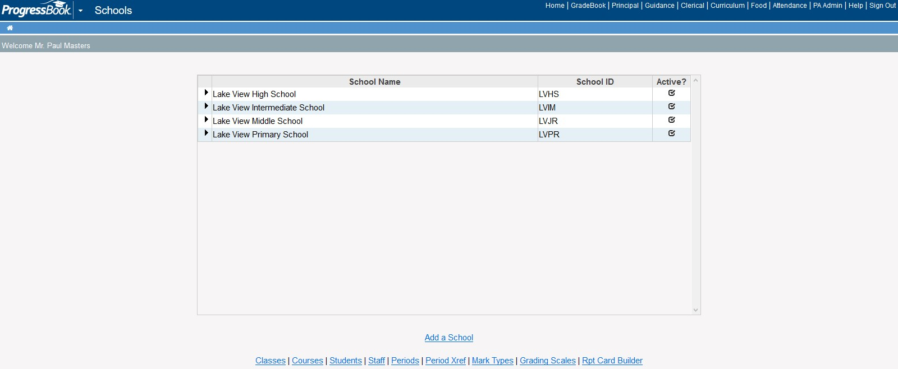

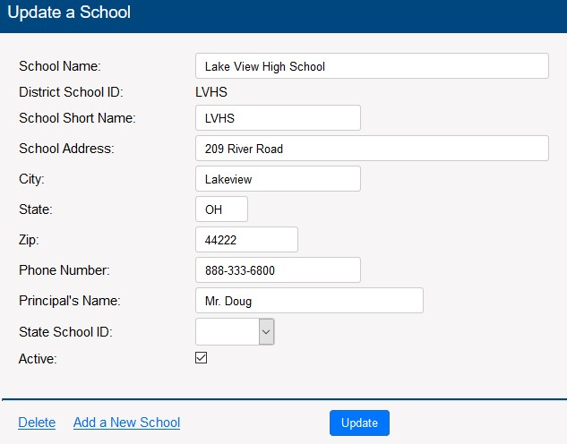

## *Grade Levels

**OME-RESA will perform this step. DO NOT add or delete grade levels.**

## *Rooms

Rooms are used in setting up homerooms and classes. The information found on this page is loaded automatically from StudentInformation.

You may click the arrow to view the school’s information. However, if you need to make any updates, you will want to update first in StudentInformation and then let the integration take place overnight for it to appear in GradeBook.

## Lunches

Lunch choices are general categories that do not change through the year. These categories may vary by building, depending on what counts are required to be reported. Lunch choices can be updated by each building by users with Principal or Clerical roles.

1. On the Administrator Home Page under District Setup, click Lunches.
2. On the Lunch Choices screen in the School list, select the appropriate school building.
3. You can perform any of the following options:
   * To add a new lunch item, in the Lunch Choice column, type the name of the item on the next available row.
   * To edit an existing lunch item, change the lunch item, as needed.
   * To delete an existing lunch item, in the Del? column, click the check box next to the item.
4. Click Save.

Note: You cannot delete a lunch choice that has a lunch count associated with it.

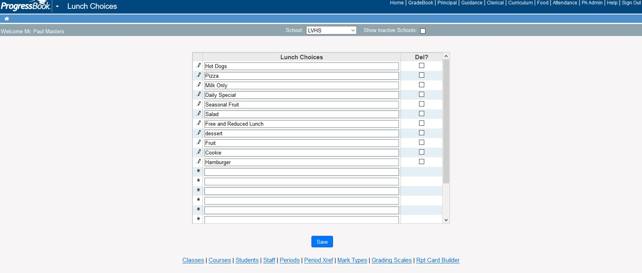

## *District Features

**Please refrain from using this section. This page is maintained by OME-RESA.**

## *School Features

**This page selects the GradeBook/PB features for your schools. This page is maintained by OME-RESA.**

Discipline

If discipline is enabled for your school, GradeBook users with the role of Teacher, Principal, Guidance, Clerk, Master or School Administrator can report discipline incidents. **If you would like this feature turned on, please send a ticket to pbstaff@omeresa.net.**

Student Search

You can specify by building whether teachers can search for students within their own classes (default), their school or entire school district. Also, you can have student photos shown in the quick view area of the search results. **If you would like to change the search within to school or entire district and/or photos enabled, please send a ticket to pbstaff@omeresa.net.**

## *3rd Party API Settings

This function is used for VirtualClassroom. **Please refrain from using this section. This page is maintained by OME-RESA.**

# Annual Setup Section

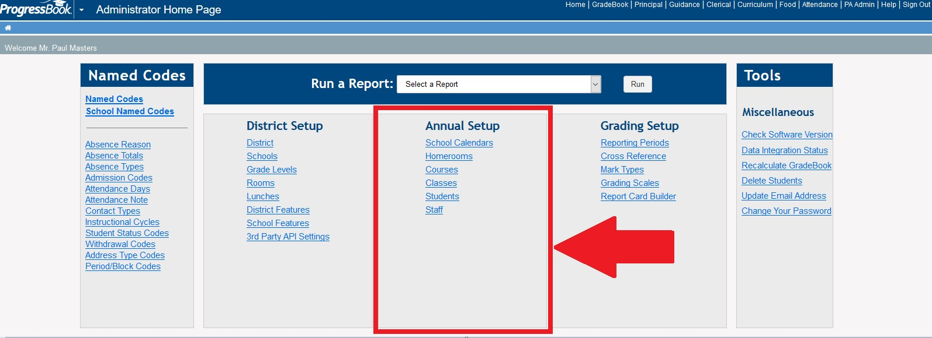

## *School Calendars

**This section refers to information that is maintained by OME-RESA. No action is to be taken by the district point of contact unless otherwise directed such as in the instance of GradeBook/PB report card attendance totaling maintenance. If you use this, we will provide you with the info you need to maintain the calendars.**

## *Homerooms

**The information found on this page is loaded automatically from StudentInformation. No action is to be taken by the district point of contact.**

## *Courses

**The information found on this page is loaded automatically from StudentInformation.** Courses are imported into GradeBook from StudentInformation in the nightly integration process. If changes are necessary, you should make them in StudentInformation.

The POC canselect the Courses With No Classes option in the banner, if desired, to limit search results to only courses that do not have associated classes. If you do not select this option, search results include both courses with and without associated classes.

The POC can use this option to exclude courses from Parent Access if needed.

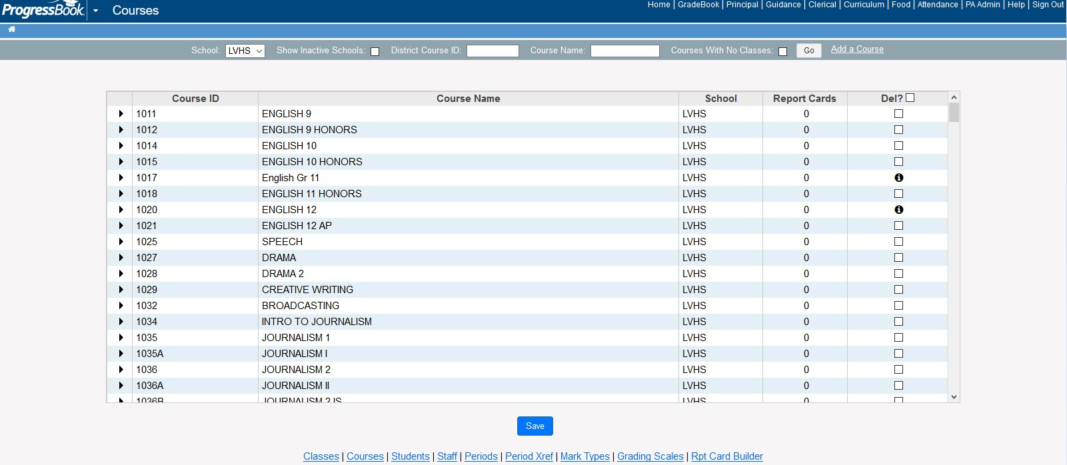

Click on the arrow in front of the course that you want to exclude from Parent Access. The following window will open:

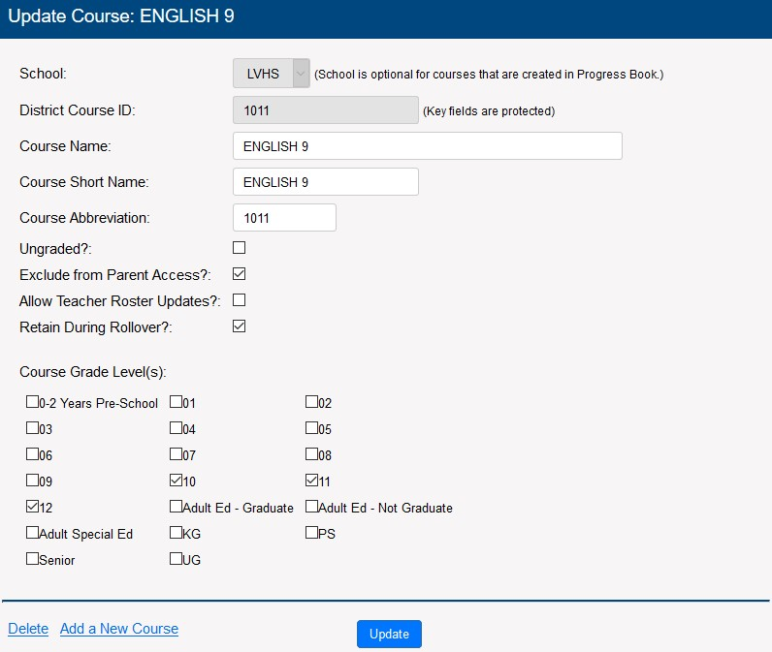

Click the checkbox next to the “Exclude from Parent Access” option and then click update to save your changes.

## *Classes

Classes are associated with courses, so courses must be set up prior to adding classes. **The information found on this page is loaded automatically from StudentInformation.** Classes are imported into GradeBook from StudentInformation. If changes are necessary, you should make them in StudentInformation.

**No action is to be taken by the district point of contact.**

## *Students

**The information found on this page is loaded automatically from StudentInformation. No action is to be taken by the district point of contact. However, the ability to stop parent access for a student is available from this screen if desired, such as due to unpaid fees, etc…**

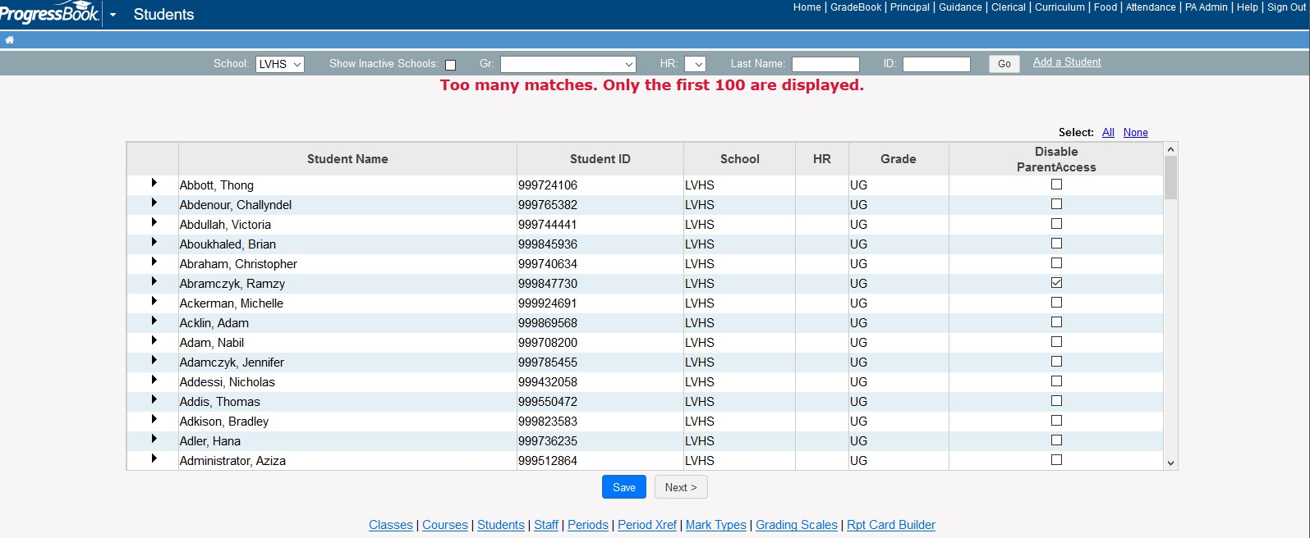

Click on the column “Disable Parent Access: and then click save to accept your changes.

## Staff

## Explanation of Roles

The following user roles are available to assign to GradeBook users.

* **Attendance** – Access to student daily and period attendance records in the Absence Queue, an attendance export to send records to the student information system, attendance reports, homerooms and period/block codes.
* **Cafeteria** – Access to update lunch choices and lunch count reports.
* **Clerk** – Access to all attendance options that the Attendance role can access as well as report cards: view report card and interim grades by student and ParentAccess user account maintenance and extracts.
* **Curriculum** **Director** – Access to lesson plans, lesson plan reports, academic standards maintenance and grading scales.
* **Guidance** – Access to student progress reports and viewing student progress on ParentAccess.
* **Principal** – Access to all clerical options that the Attendance and Clerical roles can access as well as eligibility reports and student progress reports. This role can also view student progress on ParentAccess, as well as teacher grade book information, including Grade Book Grid, 5 Day Planner, lesson plan and class progress reports.
* **School** **Administrator** – Access to the GradeBook Administrator Home Page for one or more school buildings to which they are assigned with edit privileges for codes, calendars, staff, reporting periods, courses, classes, academic standards and possibly report cards. **Only Points of Contacts should have this role.**
* **Teacher** – Access to GradeBook’s grade book features and Special Services (if it is enabled) for the classes and students to which they are assigned.
* **School** **Support** – Access to homerooms, classes, students and staff in the school buildings to which they are assigned, as well as all Principal role functionality and limited ParentAccess administration.

The following are ParentAccess roles that can also be assigned to GradeBook users in addition to the previous GradeBook roles:

* **District** **Web** **Author** – Maintains school district’s ParentAccess website content
* **School Web Author** – Maintains school building’s ParentAccess website content.

Teacher accounts

Teachers are imported from the staff member records in StudentInformation. Since GradeBook/PB uses login information from “StudentInformation” ALL staff must have a “StudentInformation” account. Once all is setup,

StudentInformation accounts will be automatically tied to a teacher record by a process that runs nightly at OME-RESA.

## Disable Staff

To disable an account click on the “check box” provided.

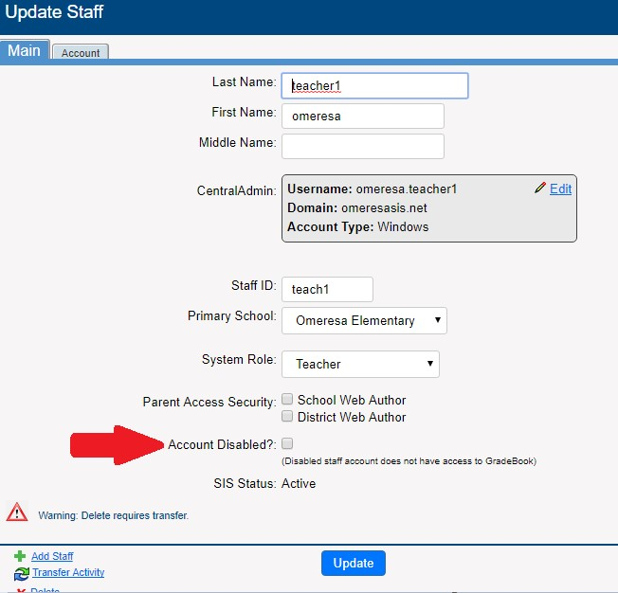

## Transfer Staff Activity

You can transfer classes, lesson plan banks, assignment banks, VirtualClassroom libraries, homework banks and SpecialServices banks that are associated with one staff record to another staff record. Transferring changes ownership of activities to the new staff record. Once the transfer is complete, the activities are no longer associated with the original staff record.

To delete a staff record that has classes and associated activities, you must transfer the activities to another staff record first before you delete them. “Warning: Delete requires transfer” displays on the Update Staff window for a staff record if there are activities in use that must be transferred. GradeBook checks staff records for the following associated activities:

* Classes
* Assignment types
* Assignments • Homework
* Lesson plans
* ParentAccess home pages
* Assignment banks
* Lesson Plan banks
* VirtualClassroom libraries
* Homework banks

Special Services banks

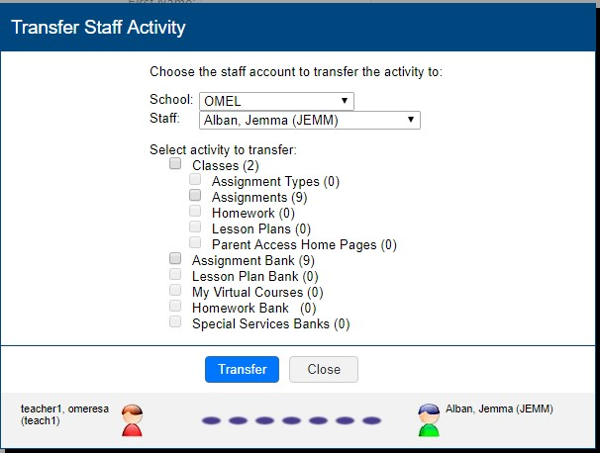

**It is recommended to transfer activities in GradeBook/PB before making schedule changes in StudentInformation.**

* 1. On the Administrator Home Page under Annual Setup, click **Staff**.
  2. On the Staff screen, search for the staff member whom you want to transfer activities from.
  3. Click in the row of the staff member you want to transfer activities from.
  4. On the Update Staff window, click the **Transfer Activity** link.
  5. On the Transfer Staff Information window, select the **school** where the staff member to whom you are transferring information is located in the School list.
  6. Select the **staff member to whom you are transferring** information in the Staff list.
  7. Select the types of **activities** to transfer.
  8. Click **Transfer**.

**The message "Transfer of staff activity complete" displays when the transfer of information is complete.**

## To delete staff members

It is recommended that you do not remove staff during the school year.

## Help a Teacher

As a point of contact, you have the privilege to access any teacher’s grade book to help them as needed. When you help a teacher in this manner, you cannot do certain tasks for the teacher because they are associated with the login that created them. For example, do not group classes together, edit the class list or create assignment types for the teacher because these will be associated with your account and not the teacher’s account.

To temporarily gain access to a teacher’s class:

1. Click on the “Staff” link under the “Annual Setup” section.
2. Search for the teacher you want to help
3. Click in the check box to the right of the teacher’s name for whom you wish to gain access for under the Help column.
4. Click Save.

**Note**: You can help only one teacher at a time. If the teacher you choose to help has multiple accounts, all accounts are selected by default so you can help that teacher across all their accounts.

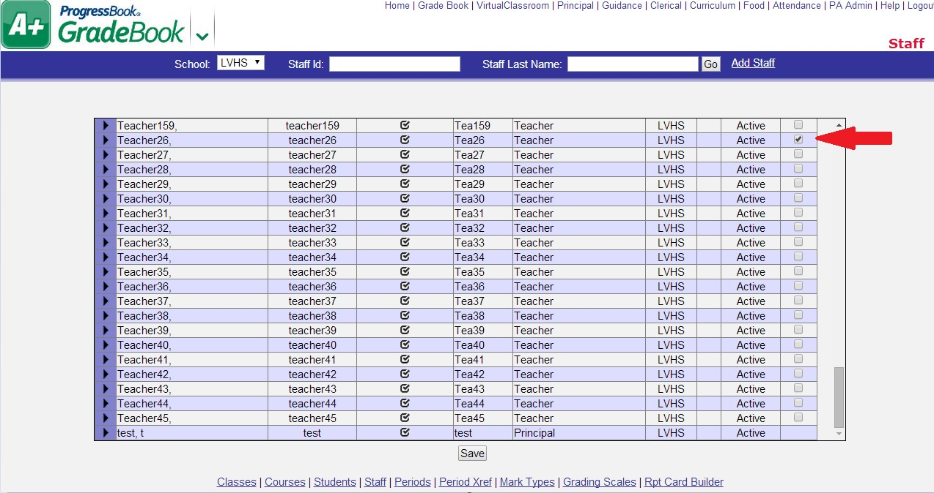

Near the top left of the screen, the name of the teacher you are helping displays.

Note: When you want to stop helping that teacher, next to the teacher’s name, click  .

1. Click on the “Grade Book” link at the top of the page.

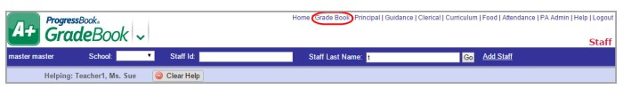

The teacher’s classes display on the Teacher Home Page.

1. Proceed to help the teacher as desired. (For details on how to do teacher tasks in GradeBook, see ProgressBook GradeBook Teacher Guide.)

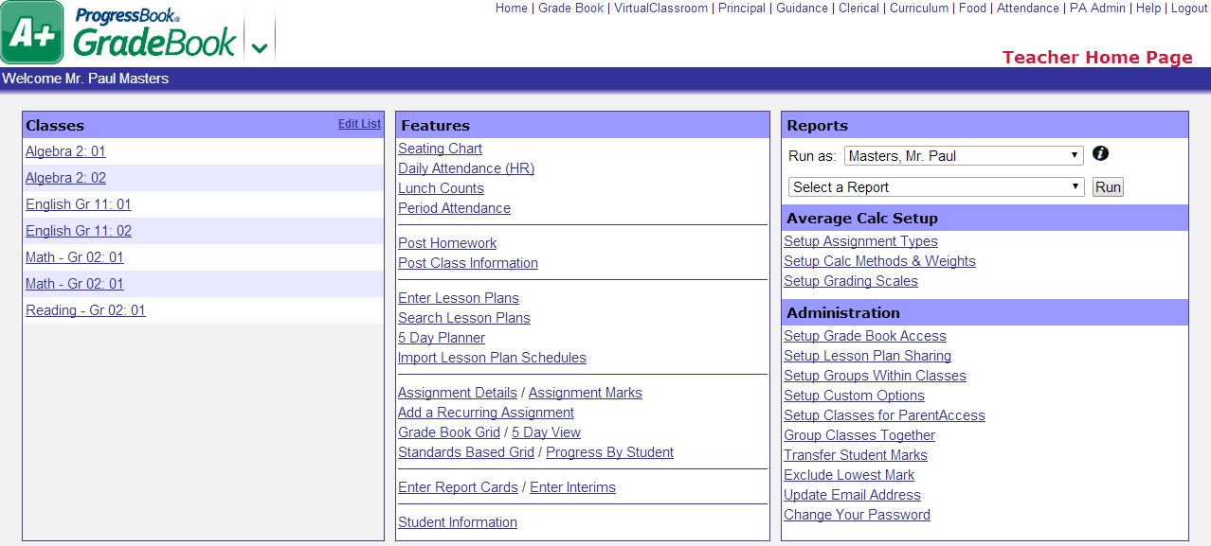

# Grading Setup Section

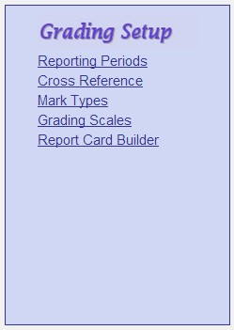

## Reporting Periods

POCs will be responsible for editing reporting period dates. Simply click on the date needing changed and edit accordingly. Then click SAVE. Only enter dates for quarter or trimester RPs. Exam, average, and final RPs are considered virtual RPs and do not need dates. These should always be gray boxes.

**Note**: Check the Gradebook Range option only for reporting periods that define where assignments should fall, such as quarters or trimesters and not on exam or final grade reporting periods.

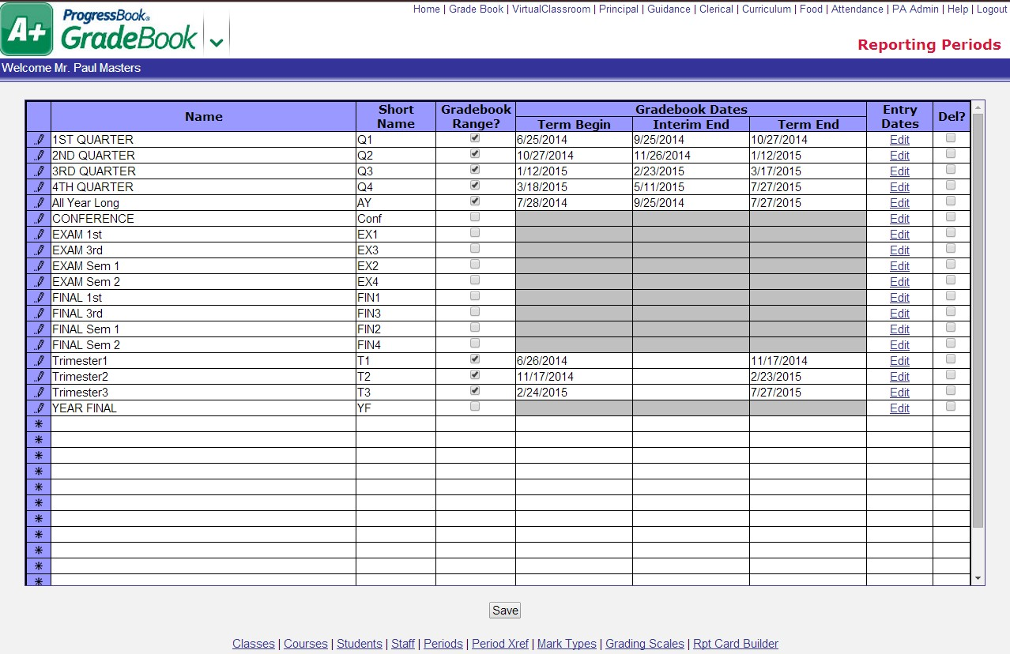

### Enter Report Card Entry Dates

You must set up specific dates in which teachers can enter interim and report card grades for each building in the school district. You can save time by using the copy option at the bottom of the screen if the entry dates are the same for multiple buildings in your district.

1. On the Reporting Periods screen in the Entry Dates column, click the Edit link in the row of the reporting period you are adding.
2. On the Report Card Entry Dates by School screen in the Entry Start Date field, enter the appropriate date and time for the building for which you are setting up.
3. In the Entry End Date field, enter the appropriate date and time

**Note**: If you do not specify a time, the system uses 12:00 AM as the beginning and ending time.

**Note**: You can save time by using the copy defaults option to enter entry start and end dates for all buildings and then modify the dates and times for individual buildings, if necessary.

1. If your school district uses ParentAccess, in the Publish Date column, enter the date and time that you want report card or interim grades to appear on ParentAccess. 5. Click Save

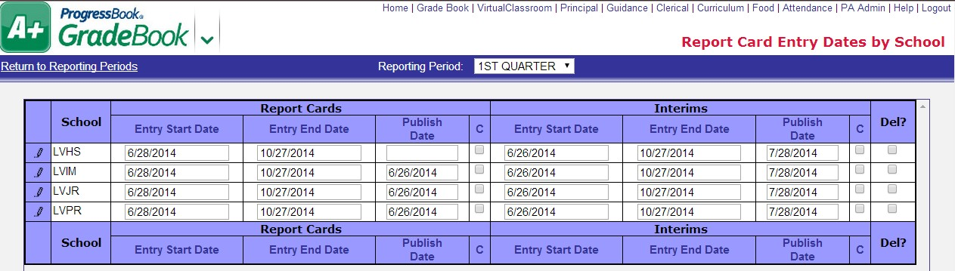

**Note:**  The “C” column has no effect now that we are on StudentInformation so it is not necessary to update this field.

## *Cross Reference

**The information found on this page is loaded automatically from StudentInformation. No action is to be taken by the district point of contact.**

## *Mark Types / Grading Scales

**The information found on this page is loaded automatically from StudentInformation and/or will be entered and updated by OME-RESA. The district point of contact will need to provide OME-RESA with their grading scale if any changes are necessary. No action is to be taken by the district point of contact. This information can be viewed by the POC for troubleshooting purposes.**

## *Report Card Builder

**This page is maintained by OME-RESA. Do not add or delete or change ANYTHING in this area.**

# Tools Section

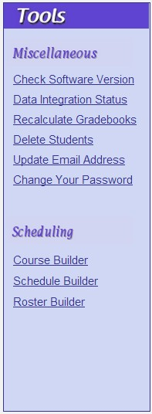

## Miscellaneous Section

## Check Software Version

Choosing this option will display the version of the software that you are currently using for GradeBook/PB.

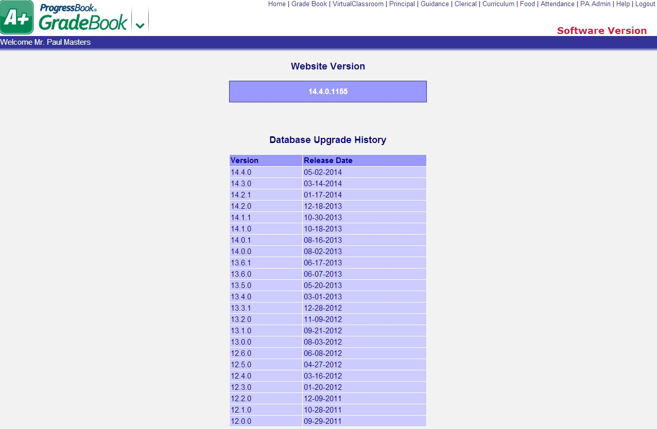

## *Data Integration Status

**This option is maintained by OME-RESA. No action is to be taken by the district point of contact.**

## Recalculate Gradebooks

GradeBook calculates teacher grade books automatically by default. However, it may be necessary to recalculate teacher grade books manually, if for example, changes are made to grading scales.

**Note: Do not do this unless necessary as it can take quite some time to do depending on the option that you select.**

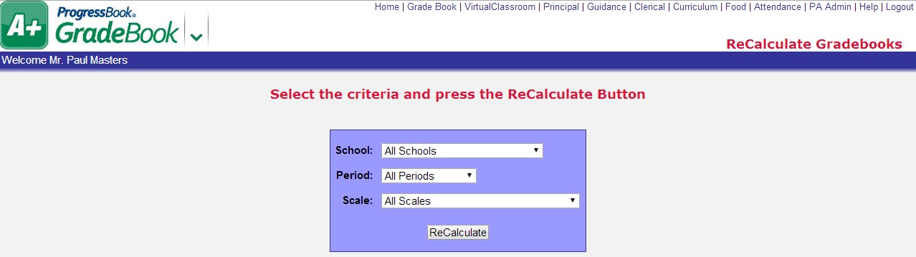

## Delete Students

The Delete Students option allows you to delete individual or numerous students at once from GradeBook/PB by specifying the appropriate search criteria. Since **this option permanently deletes all data associated with students**, make sure to carefully review the classes, assignment marks, report card marks, forms and homeroom attendance marks associated with the students before deleting.

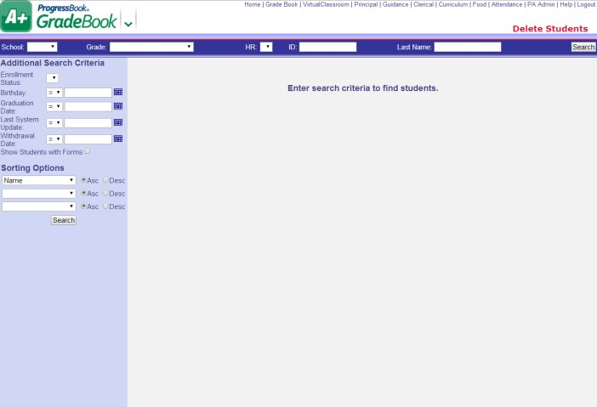

## Update Email Address

The email address you enter is used mainly for communication purposes. If you are logged into GradeBook as a teacher, the email address displays on ParentAccess

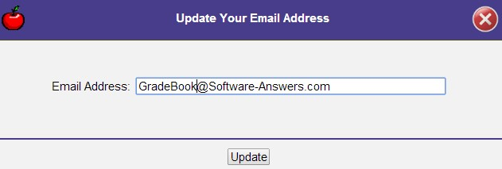

## Change your Password

Select “Change your password” link from the “Miscellaneous” section on the Administration Home Page.

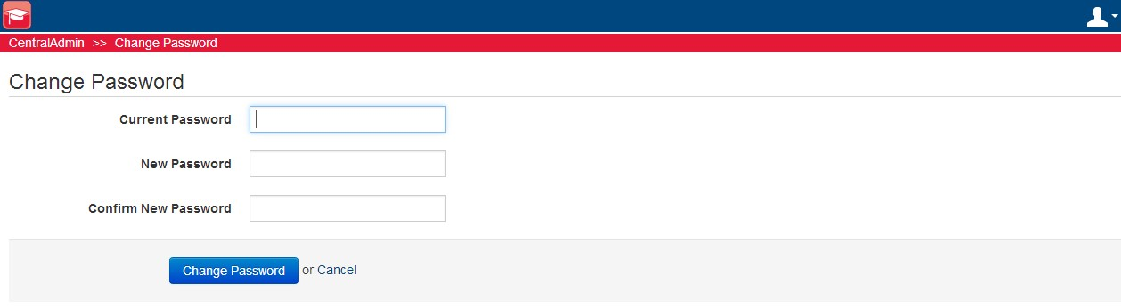

* Enter your current (old) password in the box provided.
* Enter your New Password in the boxes provided.
* Click on the “Change Password” button.

# Reports

A variety of Classic and Report Builder reports are available on the Administrator Home Page from the Run a Report list. Depending on what type of grading scale setup, such as Default, Custom Setup 1 or Custom Setup 2, is used in teachers’ classes determines if you can use a Classic or Report Builder report. “Types of Reports and Corresponding Grading Scale Setups” displays the type of reports that will work with which type of grading scale setup.

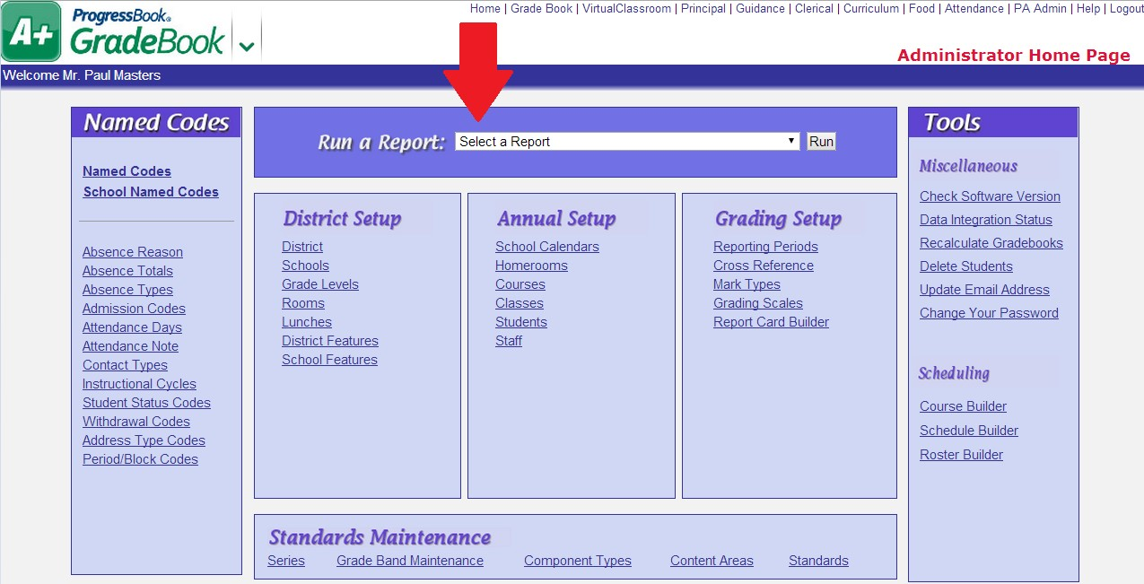

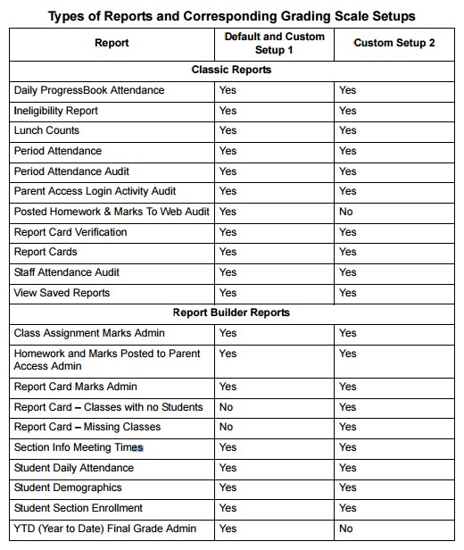

## Report Builder Reports

* **Class Assignment Marks Admin** – For Default and Custom Setup 1 teachers’ classes, the report displays class assignment mark information for individual or multiple teachers’ classes in individual or multiple reporting periods, and for Custom Setup 2 teachers’ classes, it displays class assignment assessment mark information for individual or multiple teachers’ classes in individual or multiple reporting periods.
* **Homework and Marks Posted to Parent Access Admin** – Displays assignments and assignment types for a school grouped by teacher and class within a date range with an indication of whether or not marks are posted to ParentAccess.
* **Report Card Marks Admin** –Provides numerous options for presenting report card information for individual or multiple teachers’ class(es). While this report is designed similarly to secondary report cards, it can also be used to view report card grades for elementary classes. For example, you can apply specific filter options to create a report that displays students with grades above or below a grade threshold.
* **Report Card – Classes with no Students** – Displays information about classes that are tied to courses where the course belongs to a course group on a report card, but the class has no students in it. This report includes the report card name, course name, course section and course district ID.
* **Report Card – Missing Classes** – Displays information about courses that are not included on any report cards. This report includes the school name, course name, course section, district course ID and number of students in the class/course section.
* **Section Info Meeting Times** – Displays class records for individual or multiple schools in the Sif tables and in ProgressBook tables, if the data exists.
* **Student Daily Attendance** – Displays student and daily attendance records for individual or multiple schools in the Sif tables and in ProgressBook tables, if the data exists.
* **Student Demographics** – Provides numerous options for displaying student demographic information for individual or multiple teachers’ classes, class groups or homerooms.
* **Student Section Enrollment** – Displays students’ class records for individual or multiple schools in the Sif tables and in ProgressBook tables, if the data exists.
* **YTD Final Grade Admin** – Provides numerous options for displaying year to date grade information for students in a teacher’s class or class group. The YTD Final Grade Report can only be used on classes where the YTD Grade calculation has been enabled on the report card for the class. This report cannot be used on classes using standards-based grading.

# Report Cards

Report Cards in GradeBook are set up by OME-RESA. After report cards are properly set up in the system, teachers can enter report card grades in their grade books. You can then view, generate, and print the report card information.

**Note**: In addition to Principals, users with Clerical, School Administrator, and Master roles can also generate report cards.

## Generate Preliminary Report Cards

Generating preliminary report cards creates a single RTF document that includes report cards for all students in the run. You can preview that document to determine whether you need to make any formatting modifications or data corrections. You may want to select this method under the following circumstances:

* When the report cards will be viewed only by internal staff
* When the reporting period is still open and you would like a draft copy for preview
* When you need a draft copy to assist in identifying corrections to be made in a teacher's GradeBook
* When you need a draft copy to assist in looking for formatting issues
* Any time you need to view the formatted report card but do not intend to release it

**To run preliminary report cards:**

* 1. Select Report Cards from the Run a Report dropdown list.
  2. On the Report Cards screen, select Preliminary, and in the Select a Report Card drop-down list, select the appropriate report card.

**Note**: Only active report cards display in the list.

* 1. In the Select Reporting Period for Marks area, select the reporting period(s) whose marks you want to display on the report card.
  2. If you select a reporting period with a current comment template piece mapped to it, in the Select a Reporting Period for Current Comment drop-down list, select the reporting period whose comments should display as the current comments on the report card.
  3. In the Select a School drop-down list, select the appropriate school.
  4. Optional: In the Enter student selection criteria area, select or enter any or all of the following optional criteria:

* **Grade** **Level** – Generates report cards for students in a specific grade
* **Homeroom** – Generates report cards for students in a specific homeroom
* **ProgressBook Student ID** – Generates a report card for a specific student. If you do not know the student’s ProgressBook ID number, click Search next to the field.

1. Optional: To make the report card run easy to find in the list of saved report cards, in the Enter a description for your saved reports list field, enter a description.
2. Click Submit.

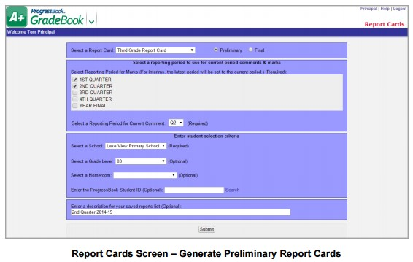

If the report cards generate successfully, Completed Successfully displays near the top of the screen.

1. Optional: To view the report cards, click View Saved Reports below the Completed Successfully message.

### View Saved Preliminary Report Cards

After you have generated report cards, you should review them for accuracy and formatting. You can go to the Saved Report Cards screen to view them.

1. Select View Saved Reports from the Run a Report dropdown list.
2. On the Saved Reports Cards screen, click the Preliminary tab.
3. In the Name column, click the name of the report card run you want to review.

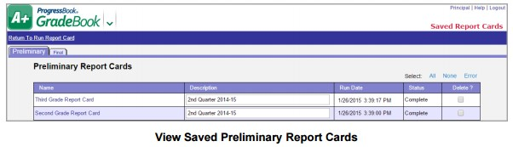

1. Open or save the file, and then review the report cards to verify accuracy or to identify required changes.
2. Optional: To delete a single saved report card file, select the check box in the Del? column for the report card you want to delete, and then click Submit.

**Note**: Saved preliminary report cards remain accessible from the Saved Report Cards screen until you delete them.

## Generate Final Report Cards

Generating final report cards creates an electronic document that parents and students can view in ParentAccess, thus eliminating the need for schools to print and mail report cards or interims. In addition to a file that includes all students, this format generates individual files for each student, so you can print individual report cards or interims in situations where a hard copy is required. You can also view each run to check accuracy and formatting before you finalize and publish the report cards to permanent storage and ParentAccess. Select this method under the following circumstances:

* When all grades have been entered
* When the report card entry window is closed and you are ready to produce report cards
* When you need to run a new report card to reflect corrected marks
* When you want report cards to be viewable in ParentAccess and stored permanently

**To run final report cards:**

1. Select Report Cards from the Run a Report dropdown list.
2. On the Report Cards screen, select Final, and in the Select a Report Card drop-down list, select the appropriate report card.
3. In the Select Reporting Period for Marks drop-down list, select the reporting period.

**Note**: GradeBook prints marks for the selected and previous reporting periods.

1. If the reporting period you selected or any of the previous reporting periods have a current comment template piece mapped to them, in the Select a Reporting Period for Current Comment drop-down list, select the reporting period whose comments should display as the current comments on the report card.
2. In the Select a School drop-down list, select the appropriate school.
3. Optional: In the Enter student selection criteria area, select or enter any or all of the following optional criteria:

* + **Grade** **Level** – Generates report cards for students in a specific grade
  + **Homeroom** – Generates report cards for students in a specific homeroom
  + **ProgressBook Student ID** – Generates a report card for a specific student. If you do not know the student’s ProgressBook ID number, click Search next to the field.

1. Optional: To make the report card easy to find in the list of saved report cards, in the Enter a description for your saved reports list field, enter a description.
2. Click Submit.

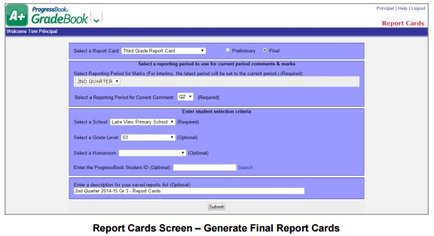

If the report cards generate successfully, Completed Successfully displays near the top of the screen.

1. Optional: To view the report cards, click View Saved Reports below the Completed Successfully message.

**Note**: After you generate report cards, if you find errors, you can rerun them before finalizing them. Report cards are not published to permanent storage or ParentAccess until you finalize them.

### View Saved Final Report Cards

After you have generated report cards, you should review them for accuracy and formatting. You can go to the Saved Report Cards screen to view them before finalizing.

1. Select View Saved Reports from the Run a Report dropdown list.

The Saved Report Cards screen Final tab displays, and the Process column shows the status of the report card run, with each step turning green as the report cards are processed. Converting report cards from RTF to PDF occurs automatically at an interval set by the system manager. You can view report cards at any stage of the process, but you can finalize them only after they have been converted to PDF.

1. In the Name column, click the name of the report card run you want to view.

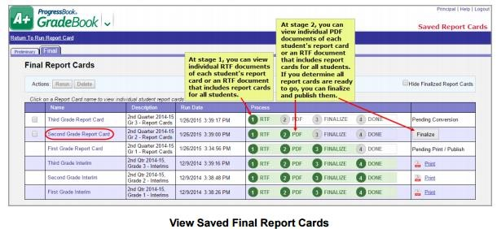

The Report Card Student List screen displays.

1. Review an individual student’s report card or all report cards in the run:
   * To view an individual student’s report card, in the Student Name column, click the name of the student whose report card you want to view.
   * To view all report cards in the run, in the Actions area, click Download Original Report Card.

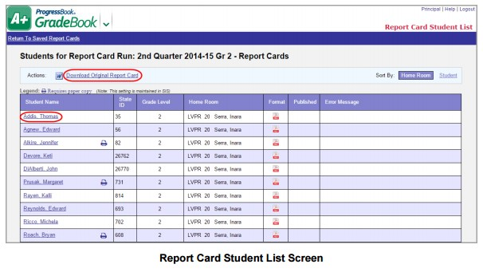

1. Open or save the file, and then review the report card(s) to verify accuracy and to identify required changes.
2. Optional: If changes are required, click Return to Saved Report Cards to either rerun or delete the report cards.

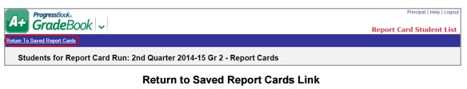

If only minor changes are necessary, ensure that the changes are made, select the check box in the row of the appropriate report card, and then click Rerun.

**Note**: Do not make changes to the RTF file because they will not be included in the rerun. If marks are incorrect, teachers should correct marks on the Report Card Entry screen for the appropriate student(s).

If significant changes are necessary and/or you want to generate the report cards again at a later time, select the check box in the row of the appropriate report card, and then click Delete.

1. Optional: If you determine that the report cards are accurate and formatted the way you want them, you can proceed to finalize them.

### Finalize Report Cards

After you determine that report cards are accurate and ready to distribute, you finalize them, which publishes them to permanent storage and to ParentAccess.

1. Select View Saved Reports from the Run a Report dropdown list.
2. In the row of the report card you want to finalize, click Finalize

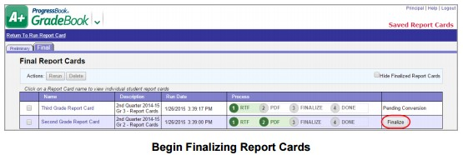

The row expands and presents an area for you to verify the display name and the date you want to make report cards available for viewing in ParentAccess.

1. In the Display As drop-down list, select the appropriate reporting period.
2. In the Available On field, enter or select the date you want this report card to start displaying in ParentAccess.
3. Click OK.

**Note**: As soon as you click OK, report cards are published to permanent storage and are viewable in

ParentAccess as of the Available On date. You can no longer rerun or delete this report card run! However, if errors are found after you finalize the report cards, you can generate and publish a corrected report card run using the same Display As reporting period and Available On date. The corrected report cards replace the incorrect ones in ParentAccess (if they were already available), and both the original and the corrected report cards are saved in permanent storage.

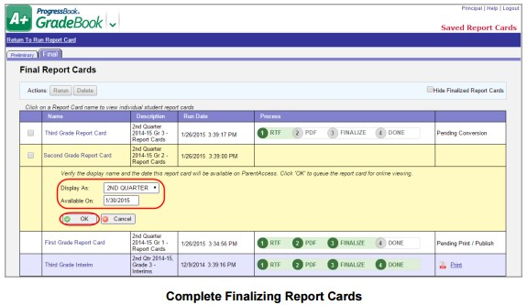

You are returned to the Saved Report Cards screen, and the status of the report card you just finalized advances to

 (Pending Print / Publish) while the report card awaits the automatic process that creates the final PDF and

publishes each individual student’s PDF to permanent storage and to ParentAccess.

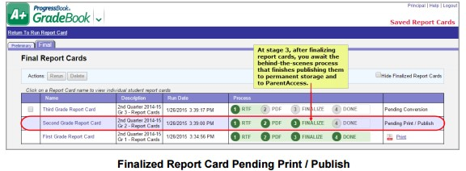

After the interval set by your system manager, the status changes to , signifying that the publishing process for this report card is complete. Once the Available On date is reached, report cards are viewable in ParentAccess.

6. Optional: To print report cards for those students requiring paper copies, click .

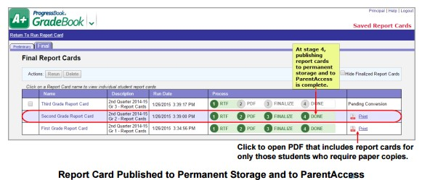

### Print Final Report Cards

If paper copies of report cards are required for specific students, a designation is made in StudentInformation, and displays next to the student’s name on the Report Card Student List screen. Print report cards as follows:

1. Select View Saved Reports from the Run a Report dropdown list.
2. On the Final tab, in the Name column, click the name of the report card you want to print.
3. Select one of the following options as desired:
   * To print a single report card for an individual student, on the Report Card Student List screen, either click the student’s name, or in the Format column, click the PDF icon.

The report card displays in PDF format, and you can use the print functionality in your PDF viewer to print it.

* + To print report cards for all students that require paper copies, on the Report Card Student List screen, in the Actions area, click View Print File.

The report cards for all students requiring paper copies display in one PDF document, and you can use the print functionality in your PDF viewer to print them.

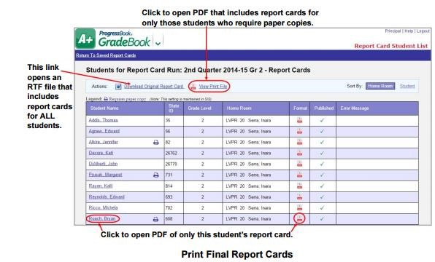

**IMPORTANT—Please use this Admin manual provided by OME-RESA. Do not use the documentation provided in the application as it is completely different. If you have any questions, please contact Student Services.**